**Setup Menu**

# Hew Lines VA7HU and Aki Yoshida JA1NLX

## 

## 5.0 RADIO MENU ITEM

The **RADIO** menu item allows the user to:

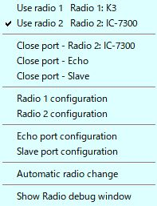

new SM_11

* + Use radio 1
  + Use radio 2
  + Open and Close (toggle) the Radio port
  + Open and Close (toggle) the Echo port
  + Open and Close (toggle) the Slave port
  + Setup Radio 1 configuration
  + Setup Radio 2 configuration
  + Setup Echo port configuration
  + Setup Slave port configuration
  + Automatically change the radio
  + Show the Radio debug window

## 